Source: https://www.linkedin.com/pulse/simulation-microgrid-portfolio-david-march/
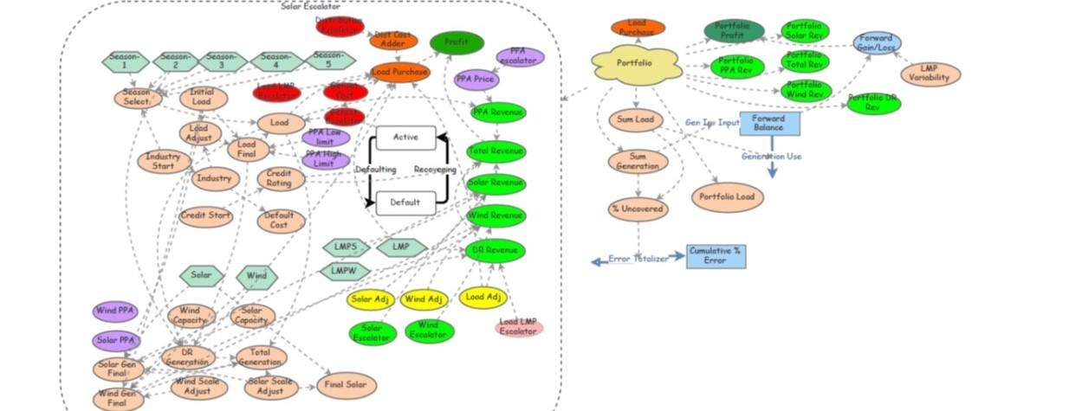
The Exergy Model: Stochastic Analysis
Summary:
Exergy’s business model requires in-front-of-the-meter renewable generation to match customer’s load profile. Extensive studies prove that a well-balanced combination of solar and wind can match electricity users’ demand curve seamlessly. However, due to the intermittency of renewable generation as well as electricity usage, a short-term mismatch of generation and load may occur.
Exergy conducted a simulation-based study using agent-based modeling methodology and concluded that such short-term variability is not only manageable, but also can be diversified.
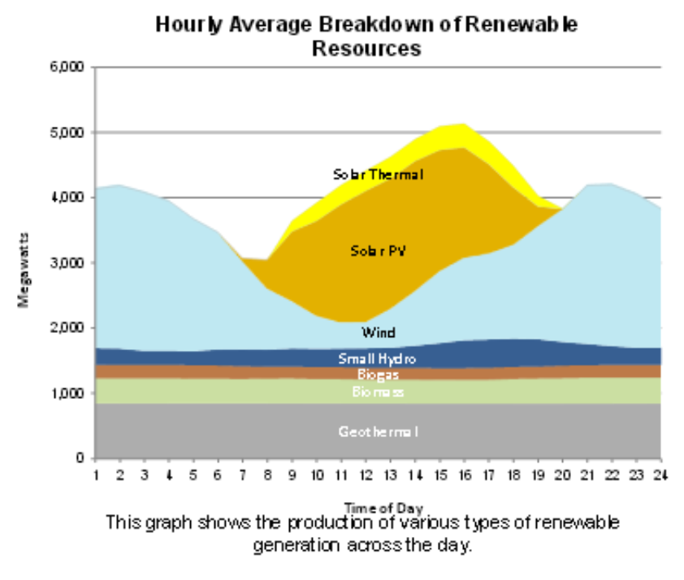
Agent-Based Simulation Methodology:
Exergy uses agent-based modeling to simulate customer load and generation output with stochastic variability assumptions. The reason for choosing this model is due to its flexibility to incorporate any assumption on each agent as well as the inter-correlation of agents.
1. Customer Load
a. Based on DOE load profile for different customer types.
i. 24 x 7 Industrial
ii. Water treatment facilities
iii. Refrigerated warehouses
iv. 24 x 7 municipal
v. 24 x 7 commercial (gas, food, supplies)
b. Load is varied by bounded Normal distribution.
i. A minimum and maximum load are set. Normal distribution with mean equal to average load. If the random generator provides a number outside the bounds it is made equal to the closest boundary.
ii. This represents both how the loads actually work and the PPA contract which has a lower and upper bound.
2. Renewable Generation
a. Our model first determines the best mix of renewable generation (type: wind, solar and hydro) to meet the load.
b. We use the P50 for each generation site.
c. We then multiply by a normal distribution of mean zero, translating negative numbers into percentage reductions, since we cannot have negative generation.
d. Each generation site has its own random normal distribution, to avoid any additional systemic correlation that is not already included in the P50. Sites (of the same generation type) are obviously correlated because of geometry (sun comes up every day, its position is a function of the year), but the short-term correlation (weather) is considered random. The adjustment by a zero mean distribution accounts for non-correlated short-term variations.
3. Nodal Pricing
a. We use the historical hourly average price at each respective node (generation and load)
b. The price is varied by a normal distribution and is allowed to go negative reflecting actual grid price dynamics.
c. From our analysis, nodal prices are highly correlated with the correlation declining with distance. Because of this we cannot use independent normal distributions for each node. We therefore use a single normal distribution as a normalized starting point. Then each node multiplies this by a bounded normal distribution, with mean zero. The boundaries are adjusted to keep the nodal correlation intact. Therefore, the bounds are increased (hence the correlation is reduced) by the distance factor.
4. Natural Gas Pricing
a. Historical delivered at the location multiplied by normal distribution of mean 1 and standard deviation of the last 12 months prices.
5. Customer PPA
a. Fixed
6. Renewable Generation Contract PPA.
a. Fixed
7. O&M costs
a. Fixed with escalator. (this is under contract)
8. Generator Uptime
a. Industry average and guarantee by manufacturer.
9. Generator performance.
a. Manufacturer commission guarantee.
10. Simulation
a. We simulated by running for 100’s of simulated years at an hourly basis with the stochastic variable changing each hour. This results in a higher short-term variance. However, given the high frequency variability of solar and wind, we believe this is appropriate.
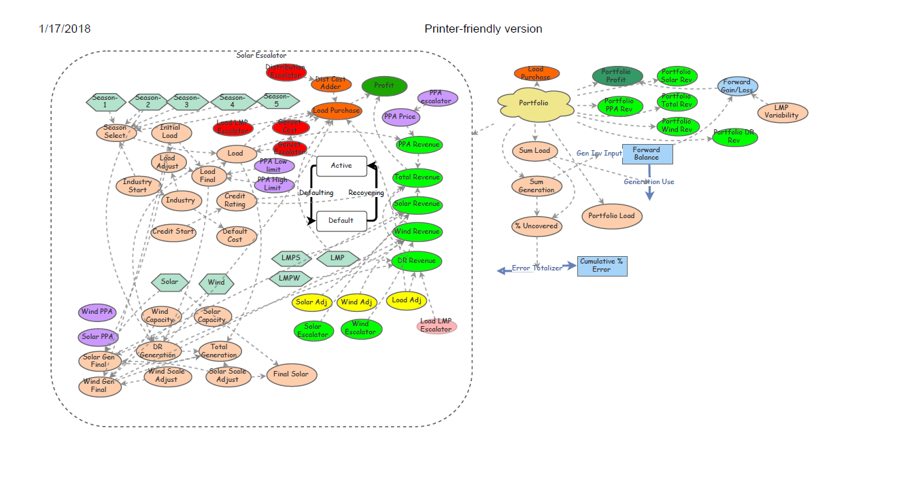
Portfolio: Agent Based Modeling
The above is how we simulate a single load / customer situation. We have also simulated different sized portfolios using Agent Based Modeling. In this process we created a number of customers described above and let them “evolve” over time. So instead of running hourly simulations for a single load for 100’s of years, we run hourly simulations for 100’s of years for hundreds of loads. This would not provide any additional information if the load model above is merely duplicated. Essentially the simulation would simply be a Taylor expansion of the stochastic coefficients.
To address this and make the portfolio model a very close fit to reality, we make changes each time we create a new load. When simulating a 100-load portfolio, each load is unique. Below is how we do this.
1. Industry
a. When an agent (load) is created, it is assigned to an industry. The industry is assigned randomly using a discrete distribution based on the expected portfolio distribution of industries of our target markets.
b. The load profile for the industry is based on the load profiles from the DOE.
c. Size of the load is a bounded normal distribution based on a mean size of our target markets and customers.
d. The load variability is also industry specific. For example, waste-water treatment has much lower variability than industrial manufacturing.
2. Credit Issues
a. Each agent is assigned a default probability based upon the industry numbers from Moody’s. The exact default rate is then determined by a randomly assigned credit rating. This is a discrete random distribution that models what we expect the credit distribution of the portfolio to be.
b. Recovery rates are based on the same logic as above.
c. When a default occurs, the assets (backup generator) are redeployed to a replacement customer after a lag time, whose average is multiplied by a uniform distribution.
3. Industry Economic Factors
a. It is assumed that agents in an industry will be influenced by industry wide economics. We simulate changes in industry demand with a bounded normal distribution based on historical numbers. Each load has a random correlation with the industry numbers based on a bounded normal distribution. Each industry’s economic factor is independent of other industries. Industries performance are not correlated at the micro-level.
4. Economy Wide Factors
a. All industries will be affected to some extent by macro-economic factors. We simulate this by a bounded normal distribution of overall economic activity that then multiples the industry economic factor. Each agent has a bounded normal random factor how it is correlated to the macro economic factors. Basically, this is the application of the industry beta to a company multiplied by a random bounded normal distribution of correlation with the beta.
5. Equipment Pricing Levels
a. We make no assumptions regarding changes in costs of generation or storage assets. Natural gas prices are assumed to remain flat in mean but are subject to a normal distribution.
Conclusion
Exergy ran simulations on various portfolio sizes. It can be concluded that the mismatch between generation and load is a short-term risk that can be addressed and minimized by increasing portfolio size and managing the diversification. A portfolio of only 20 customers can reduce the short-term mismatch error average to under 3%.

